# Chapter 7

## Computer Problems

### 7.3

c) The Figure below shows the resulting cubic spline with the data points



### 7.4

b) The figure below shows the cubic spline plot with data points.



c) The polynomial gives unrealistic values between the data points due to the oscillation. Spline plot gives a better result between data points, but it overshoots to become smoother.

d) Piecewise linear interpolation is better for this case as it gives a better estimate between the data points, but it is not very smooth.

### 7.5

The plot of polynomial with data points, square root and spline is given below



c) The spline is more accurate than the polynomial.

d) The spline is more accurate between the range of 0 and 1 as well.

## Chapter 8

## Computer Problems

### 8.1

The following figures show the results obtained from MATLAB.

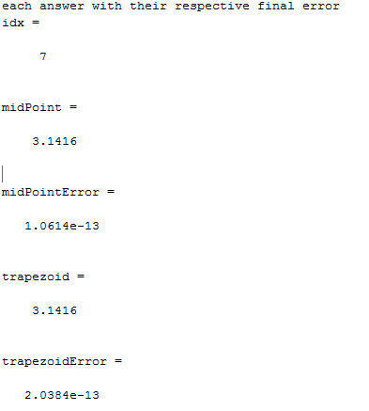

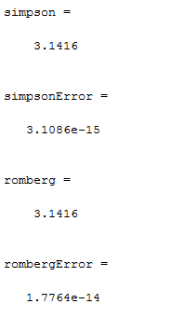

### 8.7

The figure below shows the result obtained by performing Frensel’s integrals



### 8.11

The plot below shows the result obtained of the electrostatic potential.



## Chapter 9

### Computer Problems

### 9.2

The graph below shows the result obtained of the effect of an epidemic on a population according to the Kermack McKendrick model.



### 9.7

The following are the orbital plots and the solutions to ODE across the 3 given values of e.













### 9.8

The following graph shows the solution obtained by solving the ODE



The following figure shows the spacecraft’s orbit and the positions of the Earth and moon.



The following graph shows the step size used by the ODE routine, during the integral progression.

